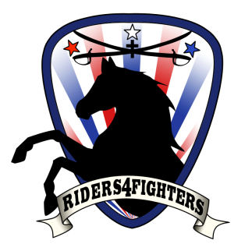 Friday, March 7, 10:00am
Midland Dr. & Tanforan
‘Riders4Fighters’ invites you to join in a “wave off” as Midland Sheriffs & ‘ Patriot Guard Riders’ escort 6 wounded Military Heroes that ‘Reel Thanx’ will be taking fishing @ Lake Amistad.
We want to salute Our Heroes West Texas style, most of them have never been to Texas and this is our way of
“Thanking Them for Their Service & Sacrifices”.
PLEASE wear red/white/or blue.
*CALL IF YOU ARE BRINGING A HORSE 2 days before.*
Come Join Us, Just bring a smile & a wave, it means more than you know to these Heroes!!!
Info: Sheila @ (505-401-9174)
US flags out on Green Tree Blvd to honor would be appreciated!

